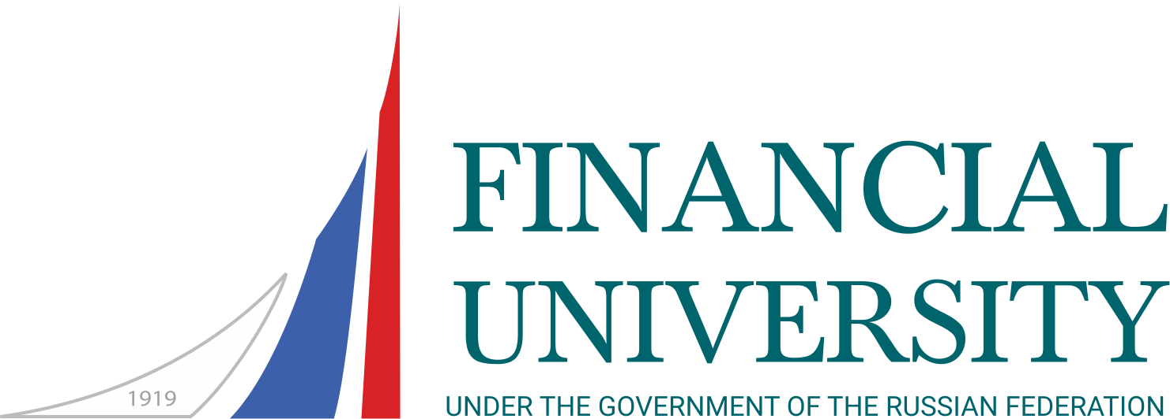 | Financial University under the Government of the RF  Russia, 125993 Moscow, Leningradsky prospekt, 49/2, room 102  Phone: +7 (499) 553 13 01; e-mail: interschools@fa.ru  Russian Language Summer School

APPLICATION FORM
12 July ― 1 August, 2023

1. Surname

2. Name |  | 3. Male |  | Female

4. Date and place of birth 5. Citizenship
Day Month Year Country

6. Passport number |  | Date of issue |  | Valid until

7. Address for correspondence 8. Contacts
E-mail:
Phone:
9. Occupation and a name of organization; educational background.
For students: name and address of the school; field and year of study

10. What is your native language?
11. What are languages spoken?
12. Rate your level of the Russian language knowledge (tick the right box)
Written | none |  | poor |  | fair |  | good |  | excellent
Oral | none |  | poor |  | fair |  | good |  | excellent
13. For what do you need the Russian language (tourism, hobby, self-education, work, other reasons)?
Please, describe briefly
14. How did you know about the Summer School?
Financial University web-site |  |  | Link from other web-site |  | Please, specify  
Internet |  |  | Other |  | Please, specify  
Friends
15. The Summer School participation costs is covered by
Participant |  |  | Sponsor (company, organization) |  | Please, specify 
Participant’s relatives
16. Please, give the names of relatives or friends who may be contacted in case of emergency
In home country
In Russia (if any)

17. Do you have any special dietary needs? If yes, please give details: _________________________
__________________________________________________________________________________
18. I hereby certify that my health allows me to participate in the Summer School programme. I am responsible for my insurance.
19. Please, indicate the country and the city, where you will obtain a Russian visa.
Date

